

MINI PROJECT (2021-22)

ON

Book recommendation system

**NAME:**  SRISTI GANGWAR

**ROLL NO:** 2014897

**SEMESTER:** 5

**SUBMITTED TO:** DEEPAK UNIYAL

Abstract

**Background**

The modern world and its enormous technologies has given a boost to a thousand book websites. Online book reading and selling websites like Kindle and Goodreads compete against each other on many factors. One of those important factors is their book recommendation system. A book recommendation system is designed to recommend books of interest to the buyer.

INTRODUCTION

Book Recommendation System is an intelligent algorithm which reduces the overhead of the people. This provides benefit to both the seller and the consumer creating the win-win situation.The Ecommerce site to network security, all demands the need for the recommended system to increase their revenue rate. The content filtering, association rule mining and collaborative filtering are the various decision making techniques employed in the recommendation system as it helps buyers by the strong recommendations as there are various books, buyer’s sometimes cannot find the item they search for. The Book Recommendation System is widely implemented using search engines comprising of data sets.

PROBLEM DESCRIPTION

The aim of this Book Recommendation Engine, or “Book Recommender” is to provide *interesting* book recommendations to the user.

The challenge with book recommendations, and unlike movie or music recommendation engines, is the vast amounts of book titles available, and the time investment for each of the books.

Book recommenders are especially useful for the kind of readers that go into bookstores (physical or virtual) without a book title in mind.

The aim of the book recommender is not to provide a high accuracy, instead, difficult to quantify insightful book recommendations.

ABOUT DATA

The Book-Crossing dataset comprises 3 files.

* Users  
  Contains the users. Note that user IDs (User-ID) have been anonymized and map to integers. Demographic data is provided (Location, Age) if available. Otherwise, these fields contain NULL-values.
* Books  
  Books are identified by their respective ISBN. Invalid ISBNs have already been removed from the dataset. Moreover, some content-based information is given (Book-Title, Book-Author, Year-Of-Publication, Publisher), obtained from Amazon Web Services. Note that in case of several authors, only the first is provided. URLs linking to cover images are also given, appearing in three different flavours (Image-URL-S, Image-URL-M, Image-URL-L), i.e., small, medium, large. These URLs point to the Amazon web site.
* Ratings  
  Contains the book rating information. Ratings (Book-Rating) are either explicit, expressed on a scale from 1-10 (higher values denoting higher appreciation), or implicit, expressed by 0.

REQUIREMENTS

**LANGUAGE USED:** Python

**SOFTWARE REQUIREMENTS:** Anaconda3 -> Jupyter

**HARDWARE REQUIREMENTS:** Windows Desktop

**REQUIRED INSTALLMENTS:**

1. Python
2. Anaconda3
3. Jupyter  
     
   Libraries:
4. Pandas
5. Numpy
6. Matplotlib
7. Sklearn
8. Seaborn

MOTIVATION

The online recommendation system has become a trend. Now a days rather than going out and buying items for themselves, reason being, online recommendation provides an easier and quicker way to buy items and transactions are also quick when it is done online. Recommended systems are powerful new technology and it helps users to find items which they want to buy. A recommendation system is broadly used to recommend products to the end users that are most appropriate.

METHODOLOGY

I used numpy and pandas for pre processing of data and knearestneighbors for our machine learning task.I have used three datset.

1.Importing all required libraries and importing dataset and displaying.

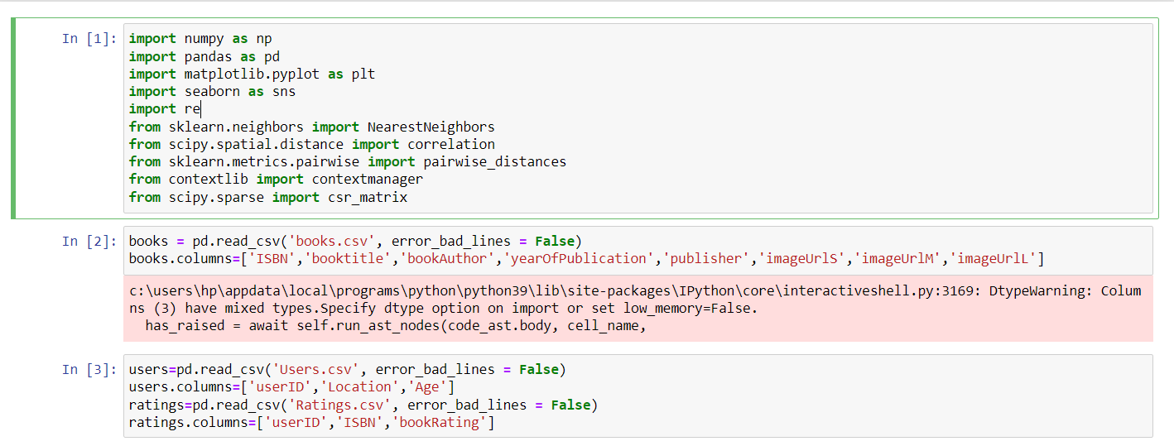

2.displaying data

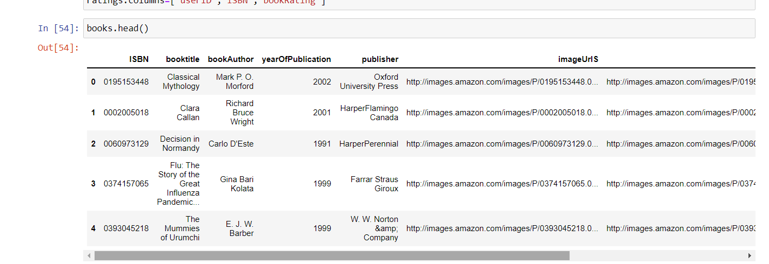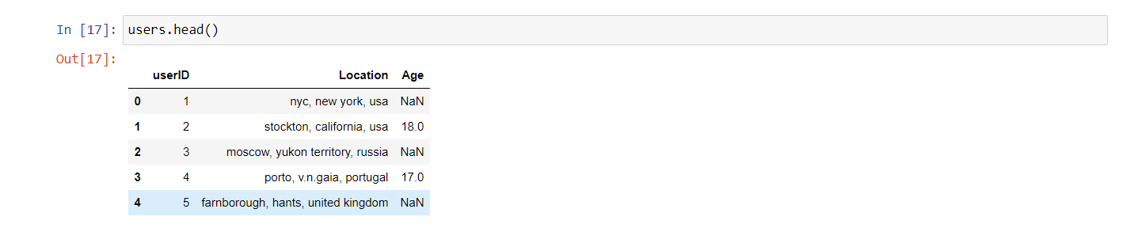

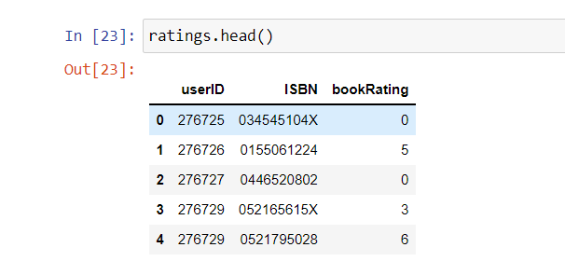

3.showing rating distribution

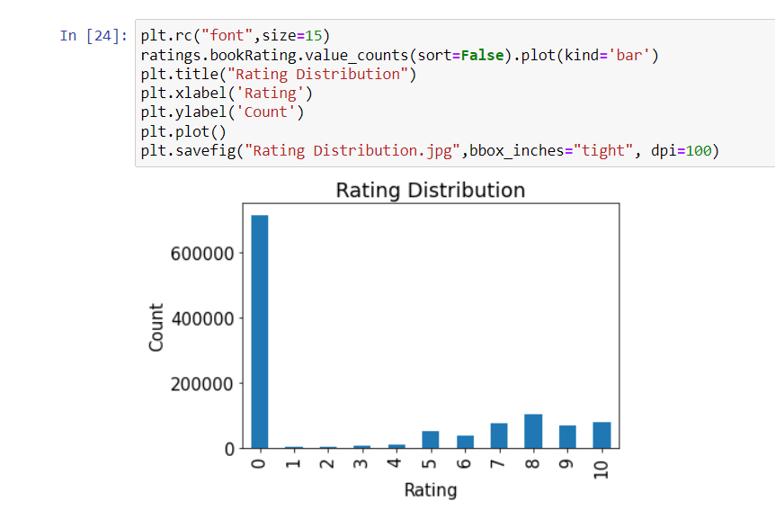

4.after some cleaning and again showing rating count plot

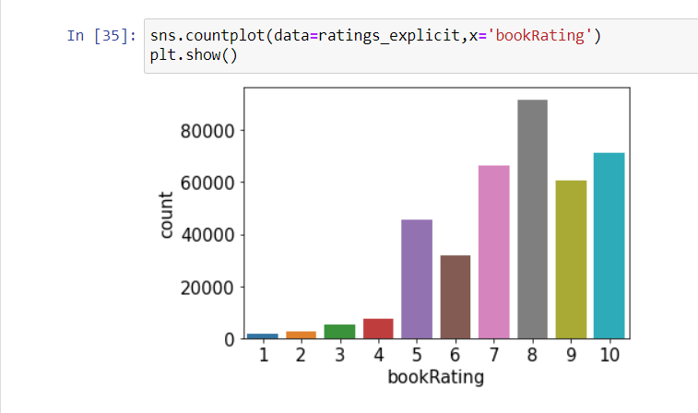

5.combining books and ratings dataframe

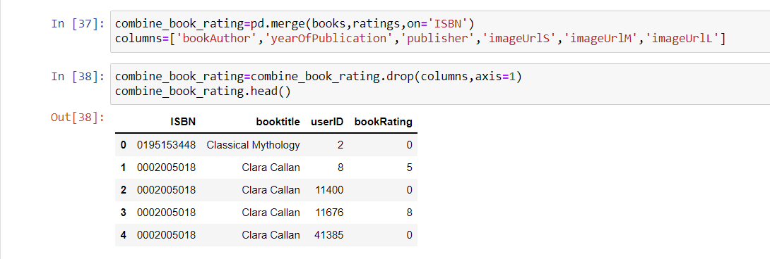

6.showing us and canada users only

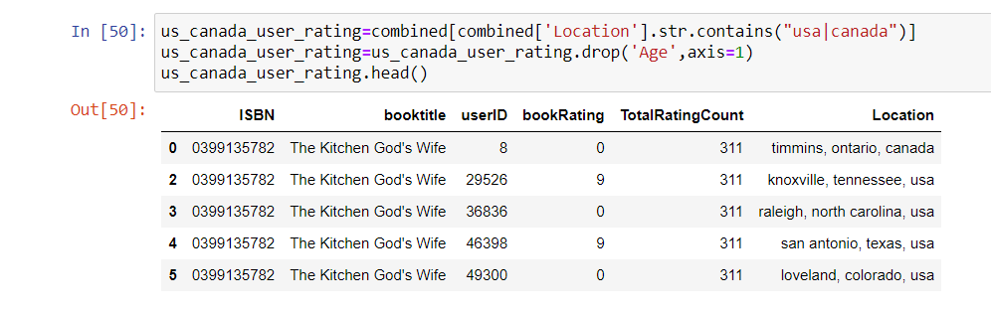

7.applying knn to only us and canada users

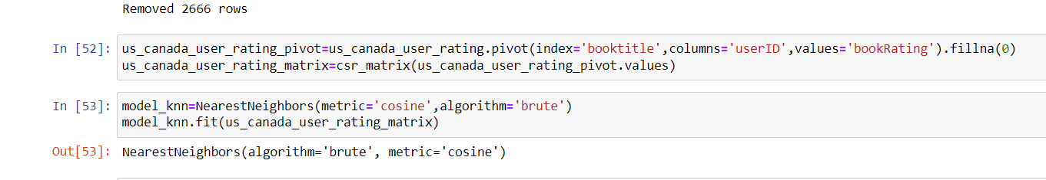

8.now finally making predictions.

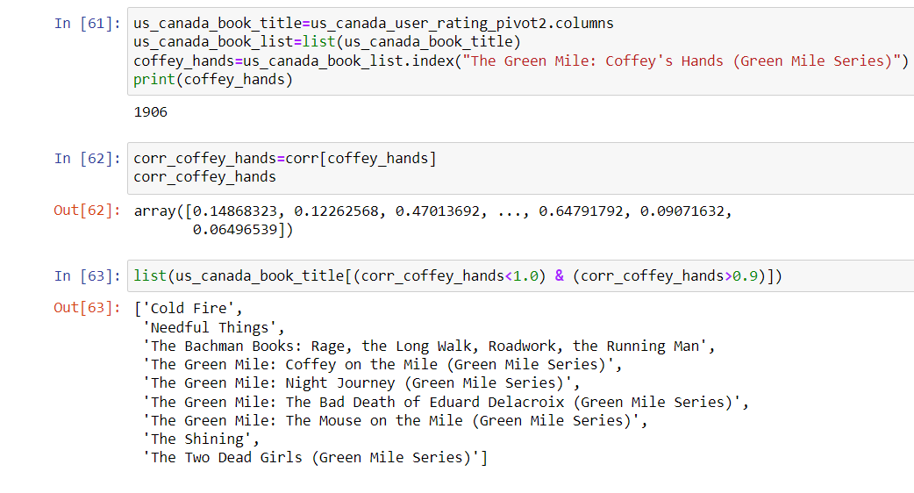

conclusions

From the above analysis, we can conclude the following points

From this analysis, we have found

This book recommender provides the user with an original, simple to use, book recommendation system emphasizing on interest book recommendations.

references

https://medium.com/@cristian.alberch/book-recommender-with-python-718449de8580

https://www.researchgate.net/publication/324795166_A_book_recommendation_system_based_on_named_entities

https: //www.goodreads.com/